KONGU ENGINEERING COLLEGE

# (Autonomous)

**Perundurai, Erode – 638 060.**



**LABORATORY RECORD**



**Name :**

**Register Number : Course code :**

**Course name : Semester & Branch :**

**KONGU ENGINEERING COLLEGE**

### (Autonomous)

**Perundurai, Erode – 638 060.**



# Department of Electronics and Communication Engineering 20CSO12- Introduction to Web Engineering Laboratory Record

Name Programme Branch Section Semester Register Number

*Certified that this is a bonafide record of workdone by the above student of the*

*Laboratory during the year 2023– 24.*

## Signature of Lab in-charge Signature of Head of the Department

Submitted for the model/end semester practical examination held on

## Internal Examiner External Examiner

**DEPARTMENT OF ELECTRONICS AND COMMUNICATION ENGINEERING ASSESSMENT RUBRICS**

|  |  |  |  |  |
| --- | --- | --- | --- | --- |
| **Scale**  **Dimension** | | **Good (1)** | **Moderate (2)** | **To be improved (3)** |
| **Conduct of Experiment (20)** | **Implementation(10)** | Proper indentation, dividing the  functionalities in to related set of web pages, incorporated additional functionalities to the website (7-10) | Improper indentation, implementation with very few web pages and no additional functionalities (4-6) | No indentation, incomplete implementation and no additional functionalities (0-3) |
| **Effective UI design (10)** | Effective design with relevant content and necessary navigations  Proper usage of Page structure elements for categorizing the content on the web pages  Attractive UI design (8-10) | Design with relevant content and necessary navigations  Improper usage of Page structure elements for  categorizing the content on the web pages  Less attractive UI design  (5-7) | Design with irrelevant content and less navigations or no navigation  No usage of Page structure elements  Simple UI design (<5) |
| **Record of the Experiment (15)** | | Written the code with proper indentation.  Included atleast two relevant output screenshots  Timely submission **(11**  **- 15)** | Written the code with improper indentation  Included only one relevant output screenshot  Timely submission  **(6 - 10)** | Incomplete code without indentation  No proper output or irrelevant screenshots  No timely submission  **(0 - 5)** |
| **Viva(15)** | | Demonstration of Good Knowledge; Audible voice, Good Eye Contact, Good level of  communication skill; Answering the questions clearly with example **(11-15)** | Average Knowledge; Audible voice, Eye Contact, Average level of  communication skill; Answering the questions **(6-10)** | Poor Knowledge; No Eye Contact, low level of message  communication; No proper answers to the questions or irrelevant answers **(1-5)** |

|  |  |  |  |  |
| --- | --- | --- | --- | --- |
| SI NO | Date | Name of the Experiment | Marks Awarded | Signature |
| 1. |  |  |  |  |
| 2. |  |  |  |  |
| 3. |  |  |  |  |
| 4. |  |  |  |  |
| 5. |  |  |  |  |

|  |  |
| --- | --- |
| **EXP.NO:4** | **DESIGN A CALCULATOR BY USING JAVASCRIPT AND POST IT IN A GITHUB REPOSITORY** |
| **DATE:** |

### AIM :

To design a calculator by using Javascript and post it in github repository.

### ALGORITHM:

1. Create a file in notepad.
2. Type all the syntaxes which are required to create the website to be developed.
3. Save the file in any name with html format(.html).
4. Once it is saved it will be saved as html document.
5. To see the output of the program which is written for the website, click the file which is being saved, it will be opened as website which includes all the details which were used in the code.
6. After it is done, create a repository in GitHub and post the code in it.
7. Thus, the webpage is designed and posted in GitHub repository.

### PROGRAM :

<html >

<head>

<title> JavaScript Calculator </title>

</head>

<body style="background-color:powderblue;">

<h1> Calculator using JavaScript </h1>

<form name = "form1">

<!-- This input box shows the button pressed by the user in calculator. -->

<input id = "calc" type ="text" name = "answer"> <br> <br>

<!-- Display the calculator button on the screen. -->

<input type = "button" value = "1" onclick = "form1.answer.value += '1' ">

<input type = "button" value = "2" onclick = "form1.answer.value += '2' ">

<input type = "button" value = "3" onclick = "form1.answer.value += '3' ">

<br> <br>

<input type = "button" value = "4" onclick = "form1.answer.value += '4' ">

<input type = "button" value = "5" onclick = "form1.answer.value += '5' ">

<input type = "button" value = "6" onclick = "form1.answer.value += '6' ">

<br> <br>

<input type = "button" value = "7" onclick = "form1.answer.value += '7' ">

<input type = "button" value = "8" onclick = "form1.answer.value += '8' ">

<input type = "button" value = "9" onclick = "form1.answer.value += '9' ">

<br> <br>

<input type = "button" value = "+" onclick = "form1.answer.value += '+' ">

<input type = "button" value = "-" onclick = "form1.answer.value += '-' ">

<input type = "button" value = "*" onclick = "form1.answer.value += '*' ">

<input type = "button" value = "/" onclick = "form1.answer.value += '/' ">

<input type = "button" value = "0" onclick = "form1.answer.value += '0' ">

<input type = "button" value = "." onclick = "form1.answer.value += '.' ">

<!-- When we click on the '=' button, the onclick() shows the sum results on the calculator screen. -->

<input type = "button" value = "=" onclick = "form1.answer.value = eval(form1.answer.value) ">

<br>

<p> </p>

<input type = "button" value = "Clear All" onclick = "form1.answer.value = ' ' " id= "clear" >

</form>

</body>

</html>

### WEBSITE SCREENSHOT :

### 

**WEBSITE LINK:**

<https://praneethapr.github.io/webexp_4/>

|  |  |
| --- | --- |
| **RUBRICS** | |
| **AIM** |  |
| **ALGORITHM & PROGRAM** |  |
| **OUTPUT & RESULT** |  |
| **VIVA** |  |
| **TOTAL** |  |

### RESULT:

Thus the calculator by using Javascript was created and posted it in github repository

|  |  |
| --- | --- |
| **EXP.NO:5** | **DESIGN A VALIDATION FORM BY USING JAVASCRIPT AND POST IT IN A GITHUB REPOSITORY** |
| **DATE:** |

### AIM :

To design a Validation form by using Javascript and post it in github repository.

### ALGORITHM:

1. Create a file in notepad.
2. Type all the syntaxes which are required to create the website to be developed.
3. Save the file in any name with html format(.html).
4. Once it is saved it will be saved as html document.
5. To see the output of the program which is written for the website, click the file which is being saved, it will be opened as website which includes all the details which were used in the code.
6. After it is done, create a repository in GitHub and post the code in it.
7. Thus, the webpage is designed and posted in GitHub repository.

### PROGRAM :

<html>

<head>

<script> function test()

{

var name = document.forms["RegForm"]["Name"]; var email = document.forms["RegForm"]["EMail"];

var phone = document.forms["RegForm"]["Telephone"]; var what = document.forms["RegForm"]["Subject"];

var password = document.forms["RegForm"]["Password"]; var address = document.forms["RegForm"]["Address"];

if (name.value == "")

{

window.alert("Please enter your name."); name.focus();

return false;

}

if (address.value == "")

{

window.alert("Please enter your address."); address.focus();

return false;

}

if (email.value == "")

{

window.alert("Please enter a valid e-mail address."); email.focus();

return false;

}

if (phone.value == "")

{

window.alert("Please enter your telephone number."); phone.focus();

return false;

}

if (password.value == "")

{

window.alert("Please enter your password"); password.focus();

return false;

}

if (what.selectedIndex < 1)

{

alert("Please enter your course."); what.focus();

return false;

}

return true;

}

</script>

<style> div

{

box-sizing: border-box; width: 100%;

border: 100px solid black; float: left;

align-content: center; align-items: center;

}

form

{

margin: 0 auto; width: 600px; display: flex;

align-items: center; flex-direction: column;

}

#in{

margin-left: auto;

}

body{ color:black;

background-color: pink;

}

</style>

</head>

<body>

<h1 style="text-align: center;">REGISTRATION FORM</h1>

<form name="RegForm" action=" " onsubmit="return test()" method="post">

<p>Name: <input type="text" size="65" name="Name" /></p> <br />

<p>Address: <input type="text" size="65" name="Address" /></p> <br />

<p>E-mail Address: <input type="text" size="65" name="EMail" /></p> <br />

<p>Password: <input type="text" size="65" name="Password" /></p> <br />

<p>Mobile number: <input type="text" size="65" name="Telephone" /></p> <br />

<p>Comments: <textarea cols="55" name="Comment"> </textarea></p>

<p>

<input type="submit" value="send" name="Submit" id="in"/>

<input type="reset" value="Reset" name="Reset" id="in" />

</p>

</form>

</body>

</html>

### WEBSITE SCREENSHOT:

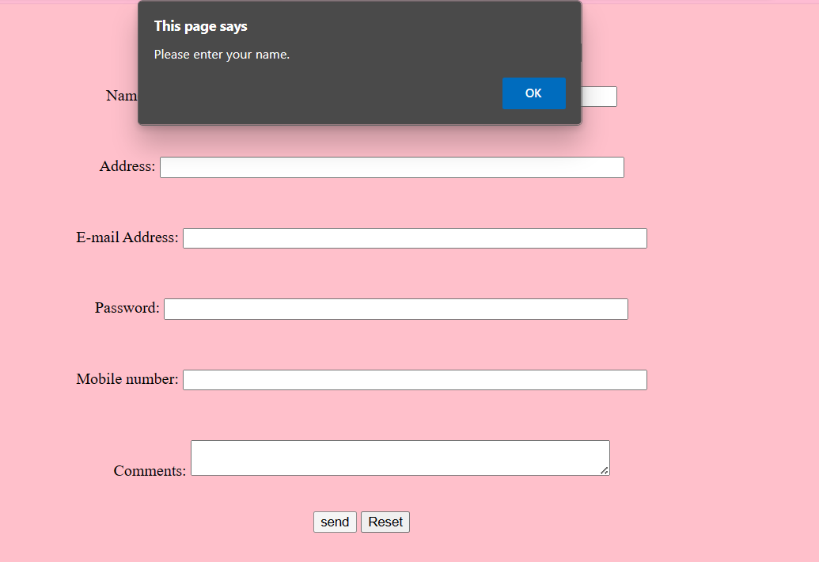

**WEBSITE LINK:**

<https://praneethapr.github.io/webexp_5/>

|  |  |
| --- | --- |
| **RUBRICS** | |
| **AIM** |  |
| **ALGORITHM & PROGRAM** |  |
| **OUTPUT & RESULT** |  |
| **VIVA** |  |
| **TOTAL** |  |

### RESULT:

Thus the validation form by using Javascript was created and posted it in github repository